**Data Warehouse Homework**

Mochammad Aditya Putra Suhendar

Group 4 – Garap Rendang

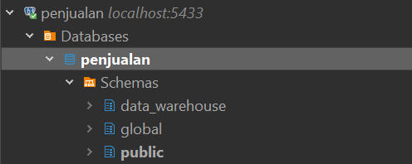

Tools: Dbeaver

Terlihat pada gambar diatas bahwasannya terdapat 2 schema (global dan data_warehouse). Schema global adalah schema dari lampiran soal, berisi tabel yang dicontohkan pada soal dengan data yang digenerate dengan query baik secara random ataupun generate series. Schema data_warehouse adalah schema yang dibuat oleh pribadi untuk menjawab soal-soal pada lampiran.

Berikut merupakan query untuk membuat dimension table dan fact table serta mengopy data dari table schema globale ke schema data_warehouse:

-- create data_warehouse schema

**create** **schema** data_warehouse;

-- create dimension table

**create** **table** data_warehouse.dim_customer (

customer_id SERIAL **primary** **key**,

customer_name **VARCHAR**(100),

email **VARCHAR**(100),

phone_number **VARCHAR**(20)

);

**create** **table** data_warehouse.dim_product (

product_id SERIAL **primary** **key**,

product_name **VARCHAR**(100),

category **VARCHAR**(50),

price **numeric**(10, 2)

);

**create** **table** data_warehouse.dim_time (

date_id SERIAL **primary** **key**,

day_of_week **VARCHAR**(100),

month **VARCHAR**(10),

quarter **VARCHAR**(10),

year **INT**

);

-- create fact table

**create** **table** data_warehouse.fact_sales (

sale_id SERIAL **primary** **key**,

customer_id **INT** **references** data_warehouse.dim_customer(customer_id),

product_id **INT** **references** data_warehouse.dim_product(product_id),

date_id **INT** **references** data_warehouse.dim_time(date_id),

quantity **INT**,

revenue **NUMERIC**(12, 2)

);

-- populate the dimension tables

**insert** **into** data_warehouse.dim_customer (customer_name, email, phone_number)

**select** customer_name, email, phone_number **from** global.customer;

**insert** **into** data_warehouse.dim_product (product_name, category, price)

**select** product_name, category, price **from** global.product;

**insert** **into** data_warehouse.dim_time (day_of_week, month, quarter, year)

**select** day_of_week, month, quarter, year **from** global.time;

-- populate the fact table

**insert** **into** data_warehouse.fact_sales (customer_id, product_id, date_id, quantity, revenue)

**select** customer_id, product_id, date_id, quantity, revenue **from** global.sales;

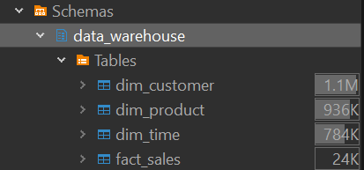

|  |
| --- |
| 1. Berapa banyak penjualan total revenue di Quarter 1 2024? |
| **select** * **from** data_warehouse.dim_time;  **select** **sum**(*fs*.revenue) **as** *total_revenue*  **from** data_warehouse.fact_sales *fs*  **join** data_warehouse.dim_time *dt* **on** **fs**.date_id = dt.date_id  **where** *dt*.quarter = '1' **and** *dt*.year = 2024; |
| Tidak ada data revenue pada quarter 1 tahun 2024. |
| 2. Berapa banyak penjualan secara quantity di Quarter 4 2023? |
| **select** * **from** data_warehouse.dim_time;  **select** **sum**(*fs*.quantity) **as** *total_quantity*  **from** data_warehouse.fact_sales *fs*  **join** data_warehouse.dim_time *dt* **on** *fs*.date_id = *dt*.date_id  **where** *dt*.quarter = '4' **and** *dt*.year = 2023; |
| Tidak ada data penjualan (secara kuantitas) pada quarter 4 tahun 2023. |
| 3. Dari semua data penjualan yang ada, carilah di Quarter berapa dan tahun berapa penjualan paling banyak secara revenue? |
| **select** *dt*.quarter, *dt*.year, **sum**(*fs*.revenue) **as** *total_revenue*  **from** data_warehouse.fact_sales *fs*  **join** data_warehouse.dim_time *dt* **on** *fs*.date_id = *dt*.date_id  **group** **by** *dt*.quarter, *dt*.year  **order** **by** *total_revenue* **desc** **limit** 1; |
|  |

[GitHub Repo](https://github.com/darhensu/Digital-Skola-Data-Engineer/blob/master/notebook/Data%20Warehouse%20Homework.sql)